Probabilistic Gaussian Generative Model

- Generative model used:

Gaussian generative model is a probabilistic model that assumes data points are generated from gaussian distribution, it assumes for prior: p(y) as the probability of each class and for likelihood: p(x | y) is assumed to follow a Multivariate Gaussian Distribution.

From training data we estimate π_k = no. of samples of k / no. of all samples
We estimate μ_k as mean of all samples of class k (the average feature for each sample of class k), Σ estimated as the shared covariance matrix representing the average variability.

The need of regularization is necessary to ensure the matrix is stable and invertible.
Lambda controls the strength of the regularization (large lambda pushes Σ towards an identity matrix).

  - 2. tested value of λ:
λ (Candidate Values) | Validation Accuracy
1e-4 | 0.94444
1e-3 | 0.94444
1e-2 | 0.94444
1e-1 | 0.94444

This indicates that the covariance matrix Σ is already well-conditioned and that the Gaussian generative classifier is not very sensitive to regularization strength on this dataset.

3. Summary of the final test results:
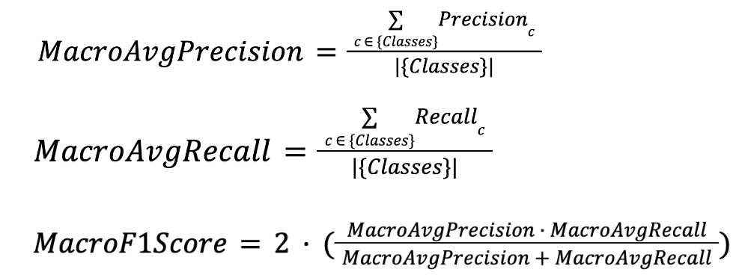
Metric | Result
Test Acc. before retrain | 0.9296
Test Acc. after retrain | 0.9629
Macro-averaged Precision | 0.9632
Macro-averaged Recall | 0.9627
Macro-averaged F1-score | 0.9625

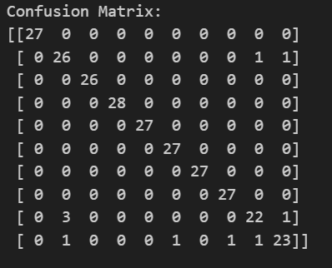
Confusion matrix:

4. Short discussion:

The Gaussian Generative Classifier achieved high performance on the test set, with a Test Accuracy of 96.32%

From confusion matrix:
Digit 8 is miss classified as digit 1 for three times.
Digit 9 is miss classified as digits 1,5,7 and 8

The choice of lambda: here choice of lambda didn’t affect the validation accuracy because for all lambdas the same accuracy was achieved.

Strength: The model achieved acceptable accuracy while it provides probabilistic predictions.

Weakness: The constraint of the shared covariance matrix limits the model's ability to create a precise decision boundary because it assumes all classes have the same shape and orientation.

